Power BI Module End Evaluation – Documentation
1. Objective
To clean a sales dataset containing missing values, duplicates and inconsistent dates, visualize order and profit trends, and use DAX to create a calculated table, column and measure.
2. Dataset Overview
The dataset holds customer order records with these columns: OrderID, OrderDate, CustomerName, Region, Product, Category, Quantity, UnitPrice, Sales, Cost and Profit. It contained about 1,020 rows with the following issues:
- Duplicate rows
- Missing values in CustomerName, Region, Product, OrderDate, UnitPrice, Sales, Cost and Profit
- OrderDate stored as text in dd-MM-yyyy format
3. Q1 – Data Cleaning and Loading
Import: Home → Get Data → Text/CSV → Transform Data (Power Query Editor).
The cleaned data was loaded with Close & Apply.
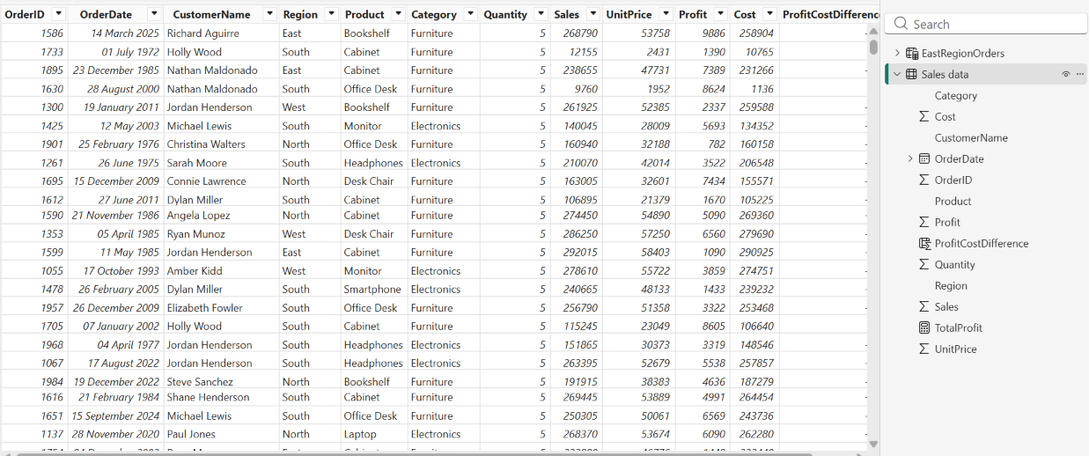
4. Q2 – Visualizations and Insights
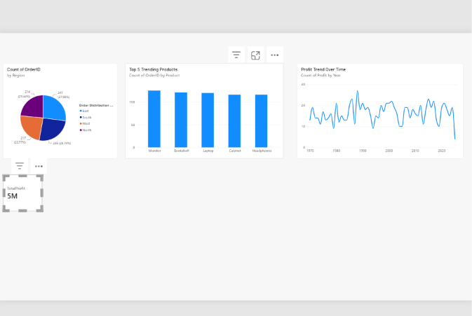Key insights
- East has the largest share of orders, followed by South, West and North.
- Monitor, Laptop, Bookshelf, Cabinet and Headphones are the most frequently ordered products.
- Profit fluctuates from year to year, with a sharp drop in the latest period.
5. Q3 – DAX Calculations
a) Calculated table – EastRegionOrders
EastRegionOrders = FILTER('Sales data', 'Sales data'[Region] = "East")
b) Calculated column – ProfitCostDifference
ProfitCostDifference = 'Sales data'[Profit] - 'Sales data'[Cost]
c) Calculated measure – TotalProfit
TotalProfit = SUM('Sales data'[Profit])
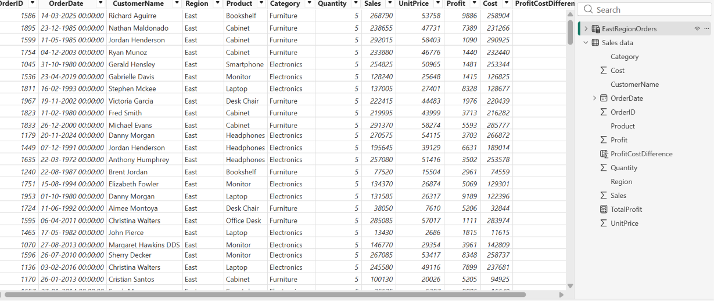
8. Conclusion
The dataset was cleaned and loaded, three visuals were built to show regional orders, top products and profit trend, and DAX was used to create a filtered table, a derived column and a summary measure. Together these give a clear view of sales performance in the data.

